CMDAV

SR SEC SCHOOL, M DABWALI
SYLLABUS CLASS IX
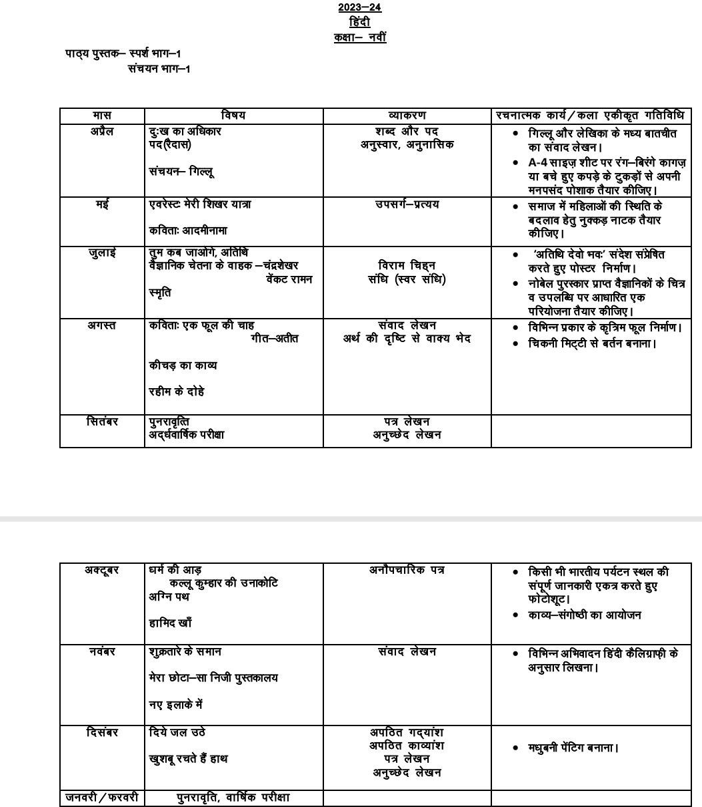
Class –IX Subject- English

Month | Literature Reader | MCB | Workbook/Gramm ar | Writing Skills | Art/Sports Integration Activities
April and May | - How I taught My Grandmother To Read  - A Dog Named Duke  - Brook  - The Road Not Taken | Unit-1 People | Verb Forms Gap Filling, Editing, Omission, Integrated Grammar | Notice Writing for school assembly/ school events/ classroom information | Project Work
July | - Villa For Sale  - The Solitary Reaper | Unit-2 Adventure Unit-3 Environment | Determiners, Tenses, Future Time Reference , Modals, Passive voice, Subject-verb Agreement, Integrated Grammar | Dialogue Writing | Preparing an itinerary
August | - The Seven Ages  - The Man Who Knew Too Much  - Keeping It From Harold | Unit-4 The Class IX Radio and Video Show | Reported Speech, Clauses, Prepositions, Integrated Grammar | Informal Letter Writing | Listening Skills
September | Revision for Half yearly Exams | Revision for Half yearly Exams | Revision for Half yearly Exams | Revision for Half yearly Exams
October | - Best Seller  - Oh, I Wish I’d Looked After Me Teeth | Unit-5 Mystery | Integrated Grammar (Revision) | Notice Writing for school assembly/ school events/ classroom information | Speaking Activity (Speech)
November | - Song of The Rain  - The Bishop’s Candlesticks | Unit-6 Children Unit-7 Sports and Games | Integrated Grammar (Revision) | Dialogue Writing Informal Letter Writing
December | Revision | Revision | Revision | Revision | Revision
January | Revision | Revision | Revision | Revision | Revision

Books Prescribed
- India and the Contemporary World – I
- Contemporary India – I
- Democratic Politics – I
- Economics

Syllabus for Class IX SOCIAL STUDIES

Month | Topic | Sub-Topic | Activities
April – May
Political Science | Ch-2: What is Democracy? Why Democracy. | - Features of Democracy, Broader meaning of Democracy. | Debate, Map work.
Geography | Ch-1: India Size and Location | - India and the world | Location of states, Union territories on the political map of India.
Economics | Ch-1: The story of village Palampur | - Organization of Production | Case Study.
July

Geography | Ch-2: Physical Features of India | - Major Physiographic Divisions. | Map work and Flipbook.
History | Ch-The French Revolution | - Condition of the French Society.
Political Science | Ch-3: Constitutional Design | - Making of Indian Constitution | Preamble making(art integration)
August
Geography | Ch-3: Drainage | - Major rivers and its tributaries. | River Map of India
Economics | Ch-2: People as Resource | - Human Resource, Human Capital | Role Play
History | Ch-Socialism in Europe and the Russian Revolution | - The First World War and formation of Soviet State.

Political Science | Ch-4: Electoral Politics | - Meaning of Election,  - Need of Election. | Mock Elections (Art – Integration)  Making of Election Manifesto(art integration).
Geography | Ch-4: Climate | - Climatic Controls, Distribution of rainfall | Find out the food ,festivals associated with seasons.
September
Political Science | Ch-4:Working of Institutions | - How is major policy decision taken Parliament Political Educative Judiciary. | Crossword , Newspaper Activity.

Economics | Ch-3:Poverty as Challenge | - Cause of Poverty, Vulnerable Groups, Comparison of Poverty in different states. | Case study (Art – Integration)
History | Ch-Nazism and the Rise of Hitler | - The basis of Hitler’s rise to power. | Locating the major countries of Second World War
October
History | Ch-Nazism and the rise of Hitler | - Ideology of Nazism

Economics | Ch-3 Poverty as Challenge | - Poverty Alleviation Programmes
November
Political Science | Ch- 5 :Democratic rights | - Democratic Rights | Picture comprehension (Art Integration)
Economics | Ch-4:Food security in India | - Public distribution system, Role of cooperative in Food security
History | Ch-Peasants and Farmers | - History of the emergence of different forms of rural societies.
December
Geography | Ch-5:Natural Vegetation and Wildlife | - Types of vegetation | Collection of Newspaper Cuttings related to the Wildlife.(Art integration).

Geography | Ch-6:Population | - Population size, distribution, age-sex composition Population change – migration National Population Policy. | Data Analysis.
January -February | Revision

MATHEMATICS

Month | S.NO. | Chapter | S.NO. | Activity
April | 1  2 | Number System Polynomials | 1 | Construction of square root spiral
May | 3  4  5 | Co-ordinate geometry Linear equations  Euclid’s geometry | 2 | Discussion on an application of co- ordinate geometry in  daily life
July | 6  7 | Lines and angles Triangles | 3 | Verifying: (x+ a) (x+ b)  =x^2 + (a+ b) x +ab
August | 8 | Quadrilaterals | 4 | To prove that opposite sides of  ||gm are equal
September | 9 | Circles | 5 | To verify that the quadrilateral formed by joining the mid points of a quadrilateral is a  ||gm
October | 10  11 | Heron’s formula  Statistics | 6 | Verifying the mid- point theorem by  cutting pasting
November | 12 | Surface area and volumes | 7 | Design a crossword puzzle with mathematical terms
December | 13 | Probability | 8 | Observing interesting patterns in cricket  match
 |  |  | 9 | Volume of cone = 1/3 of cylinder
 |  |  | 10 | Parallelograms on same base and b/w same parallels are equal in area
 |  |  | 11 | Experimental probability of outcome of a die
 |  |  | 12 | PPT on quadrilaterals/circles/triangles/statistics

